swarmathon 2

advanced bio-inspired search

# follow the trail

Have you ever seen a solitary ant find a pile of food, only to be followed by a whole line of ants just a few minutes later? Have you ever wondered how they do that? Stigmergy is the answer.

## what is stigmergy?

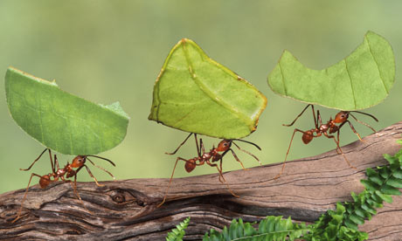Stigmergy is communication that occurs through the environment, rather than from person to person. Ants employ stigmergy by laying a chemical pheromone trail that other ants can follow. Laying pheromone allows an ant to signal to other ants where resources are without direct communication. Ants also reinforce existing trails if they are still useful.

*NatGeo*

In Swarmathon 2, we will build on some base concepts from Swarmathon 1. In Swarmathon 1, we worked extensively with robots-own variables that represented each robot’s memory and state. To implement stigmergy, we’ll need to work with the “ground” in Netlogo—the patches. To this end, patches-own variables and variables that change their value over time are introduced.

# getting started

## file setup

As in Swarmathon 1, we will be using Netlogo base code and a background image.

* Create a folder named *yourlastname _Swarmathon2.*
* Place the .nlogo file and the .jpg file in your new folder.
* Open the .nlogo file.

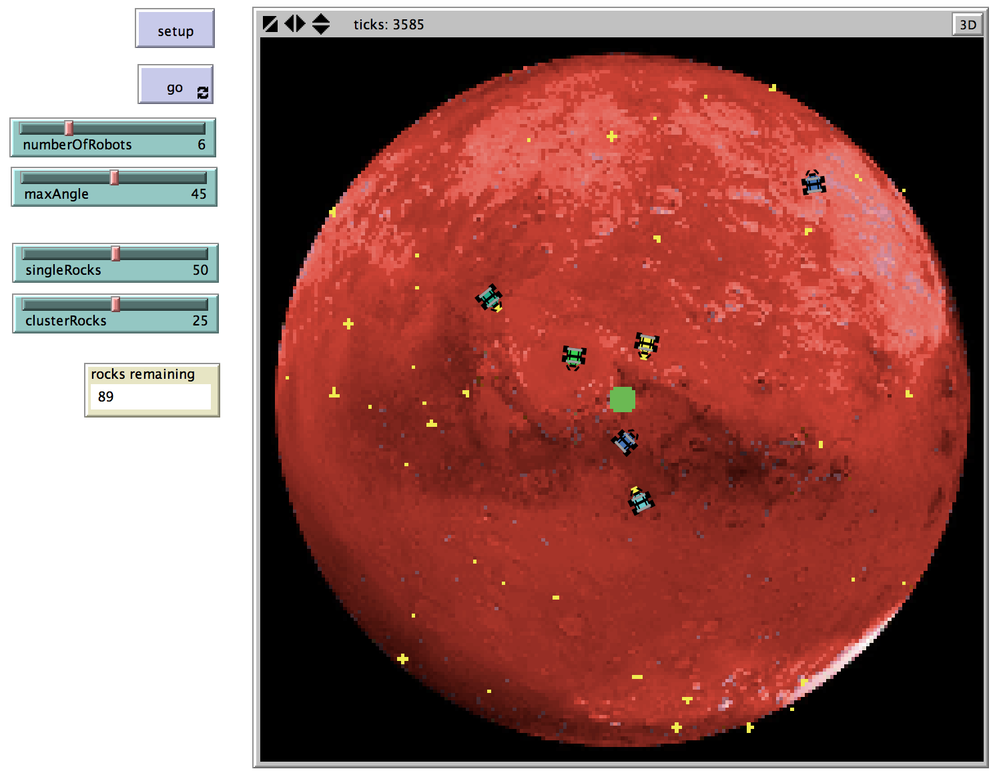Click the setup and go buttons. The robots should search for rocks and return them to the base.

Click on the Code Tab. Note that the base for this model has been included. Note that the **End of Section Challenges** from Swarmathon 1 are also completed. Check your answers!

GREAT JOB! You completed Section __.

**END OF SECTION CHALLENGE:**